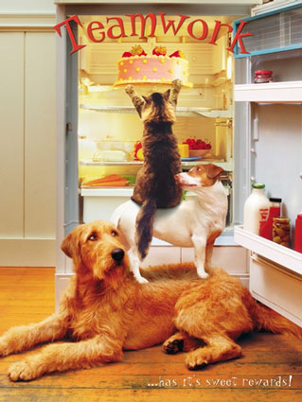
Together Everyone Achieves More

If we look at companies, some companies are flourishing with excellent profits; and some are struggling to survive. Immediately we can name one or two leaders who no doubt are behind the successful organizations. But it is not the struggle of the leader alone; in addition to the leader we can always find a good, hardworking and dedicated team behind all the success. The advantages of team building events are so many that almost all corporations have incorporated team building strategies and schedules to their standard training curriculum.
Once there was a competition going on and the event was to eat food without folding their elbows and after some deliberations among the participants they started feeding each other. Win - win situation for every one, without helping each other every one would have lost (or they would have to lick food like dogs – which will be below their dignity).

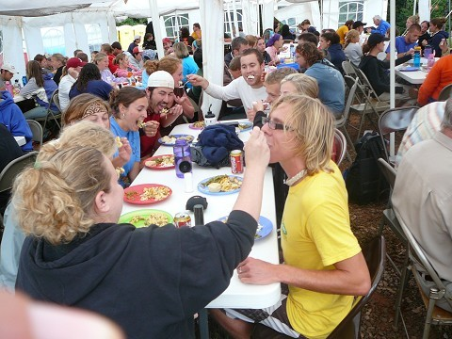
Win - Win

Action learning, as a system for improving both individual and organizational performance, it is difficult and costly for people to take time off work to go and attend courses. Therefore, this system is designed for people to use their jobs as the basis for learning.
Initially, this was implemented by coal mine managers. All the managers formed a group, to share and compare what they were doing in each of their mines. An essential part of this process was to visit each other's work place. On these visits, two things were required. Firstly, the host manager gave the visitors a tour and explained what he thought his mine and staff members were doing well, and also what they were not doing so well. Secondly, the visitors were invited to comment on what they had seen, and to give advice to the host manager.
In the subsequent weeks, each manager invited his colleagues to his own coal mine, and the process therefore became a mutual action-learning group, or 'Set' as it was called. The results were dramatic. Not only did the managers learn with and from each other, but they went back to their own coal mines and applied the things they had seen and discussed. Improvements began to occur. For example, because one mine manager was controlling costs well, and showing the others how to do it, the other members were able to see how they could do it. Another manager had low accident rates and indicated what he was doing. Another outlined how he dealt with absenteeism, and another with how to improve quality.
The sharing and comparing between the managers had a big effect, not only on the mine operations, but also on the individual managers themselves. They began to realize they could do far more than before. They gained confidence and inspiration from each other. There was also an element of taking pride in showing others what could be done. Mutual cooperation, as well as the competitive element, provided the grounds for success. In the process, they were learning not just the technical aspects of how to solve problems, but the interpersonal team and management issues of how to get people together to discuss the problems and opportunities.
UNITED We STAND
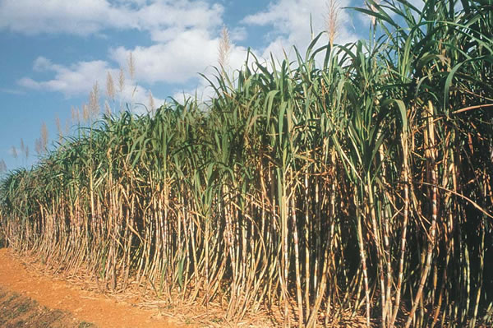
Sugar Canes individually cannot stand on their own after growing tall – so, to withstand the winds, storms and the like, every cane is tied to the next cane by their leaves, like this entire field is networked, and now strong enough to stand.

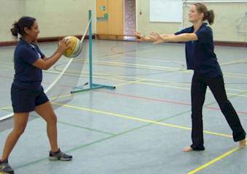
Team Building Game

Tennis Balls: Divide the participants up into small groups of about eight to ten people and have them arrange themselves in a circle. Give a tennis ball to one person and explain the rules of the game:
1. Each group is in competition with the other groups in the room. The group who can complete the most "circuits" in a given time will be the winner.
2. A completed circuit occurs when every person in the group has touched the tennis ball.
3. Only one person in the group can touch the tennis ball at one time (therefore the ball must be tossed rather than passed.)
4. If the ball ever touches the floor, then production must stop for one-minute.
Have the teams complete a few circuits to get comfortable and begin creating patterns that make them more efficient. The facilitator may want to stop the groups and get feedback as to how they are becoming more efficient and help them understand that this is a natural progression in business as well. Have the groups continue to complete circuits, but as time progresses, the facilitator will add additional rules to make the process more difficult.

* A Co-Worker calls in Sick--Remove one of the group participants and tell the group that the participant called in sick. After they complete a few circuits, remind them that just because someone calls in sick, doesn't mean that that person's work doesn't need to be completed. (They will probably have just continued to complete the circuit just as they had before the person left.) Remind them that each of their last few circuits have had one fewer touches than before, so they do not count. Someone will have to pick up the slack for the absent person. After a new pattern is established, have the person come back.
* Double Production--Throw a second ball into the mix and tell the group that our client wants us to double production. Only one ball can be held by any one person at a time. You can add a third or even fourth ball later.
Play Time

3 ways to create fun and teamwork in businesses.

1: be there for co-workers. The biggest ways to do this is by smiling, acknowledging and interacting with people while walking by them.
2: play at work. Playing helps energize the workplace. Have theme days where everybody dresses up differently. Having office parties helps unite play and team because everyone gets together. Create bulletin boards and decorate the office with fun stuff ensuring everyone’s involvement. Making work fun helps work to get done and makes people want to participate in a team.
3:
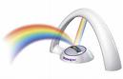
When working as a team it is very important to remember team means “we” not “I” that is why it is so important to help the team work easier. There is no "I" in "TEAMWORK".

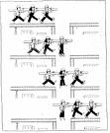
Let us resolve to start transferring decision making responsibilities from individuals to teams. For example: HR teams lead by GM HR will decide policy matters regarding to HR, similarly GM (operations) will lead an operations team to decide issues related to operations. This will go with the saying “two brains are better than one”. Almost all advantages of corporate team building are noticed on a long term basis. Corporate team building ensures a contented workforce devoted to the company.
Wishing you Happy & Successful teamwork.

